Git – Commands Assignment
Contents
Instructions:.............................................................................................................. 1
TASK 1: Repository Setup ........................................................................................... 1
TASK 2: Branch Creation & Work ................................................................................. 2
TASK 3: Branch Switching Observation ........................................................................ 2
TASK 4: Undo a Mistake .............................................................................................. 2
TASK 5: Merge Feature Branch (6 Marks) ...................................................................... 3
TASK 6: Checkout a Commit (Detached HEAD) (4 Marks) .............................................. 3

Instructions:
- This is a local Git assignment only
- Do NOT use GitHub
- Use Command Prompt / Terminal
- Commit messages must be meaningful
- Screenshots for each step in each task
- Follow steps in sequence

TASK 1: Repository Setup
Goal: Initialize Git and create first commit Steps:
- Create a folder named git-assignment-yourfullname
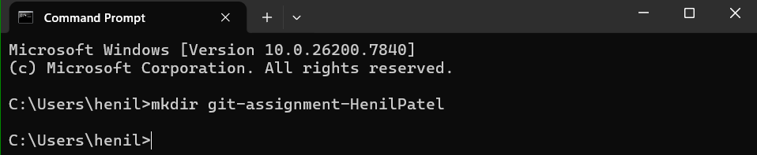
- Navigate into the folder
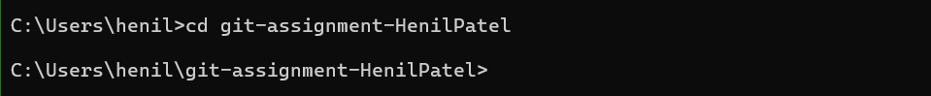

- Initialize Git repository
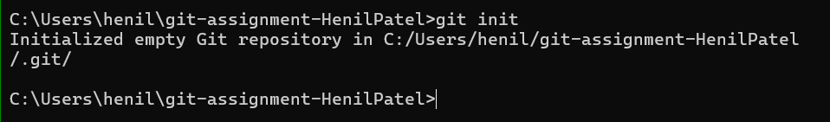

- Create a file named index.txt

- Check repository status
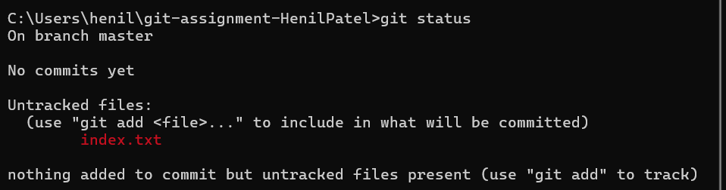

- Stage the file 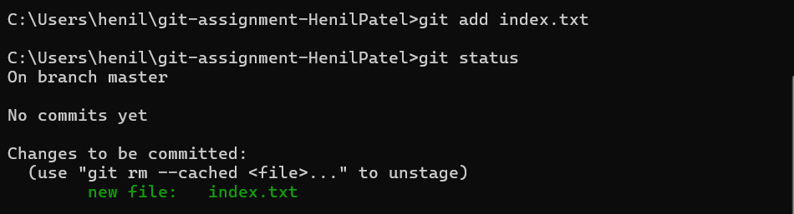

- Commit with message: Initial project setup

TASK 2: Branch Creation & Work
Goal: Work independently in a branch Steps:
- Create a branch named feature-header
- Switch to feature-header
- Create a file named header.txt
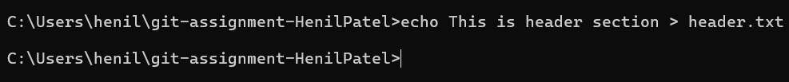
- Stage the file

- Commit with message:
Added header section
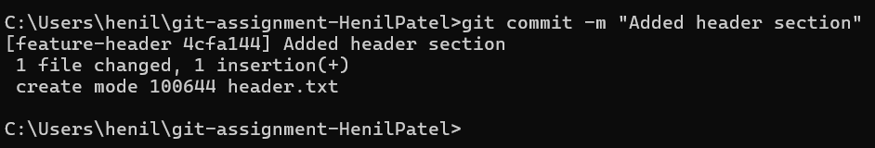

TASK 3: Branch Switching Observation
Goal: Observe branch isolation Steps:
- Switch back to master
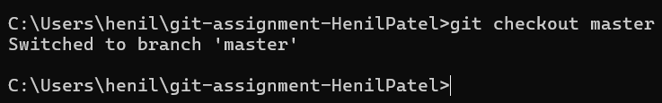
- List files and observe
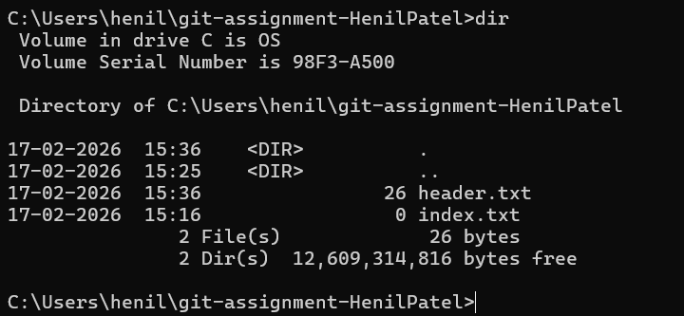

- Switch again to feature-header
- List files and observe
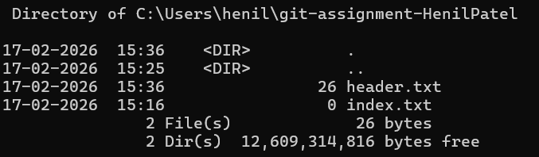

TASK 4: Undo a Mistake
Goal: Safely undo file changes Steps:
- In feature-header, modify index.txt
- Check repository status
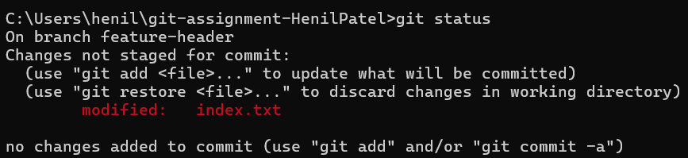

- Undo the change using Git
- Verify status again
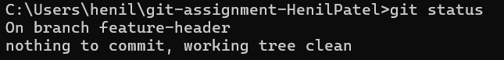

TASK 5: Merge Feature Branch
Goal: Combine work into master Steps:
- Switch to master
- Merge feature-header
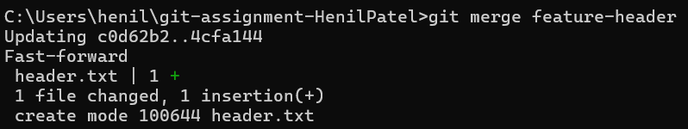

- Verify merged files
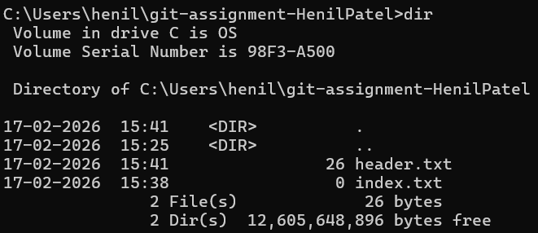

- Check commit history
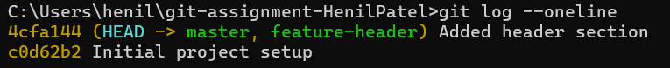

TASK 6: Checkout a Commit (Detached HEAD)
Goal: Understand commit-level navigation Steps:
- View commit history
- Checkout any older commit
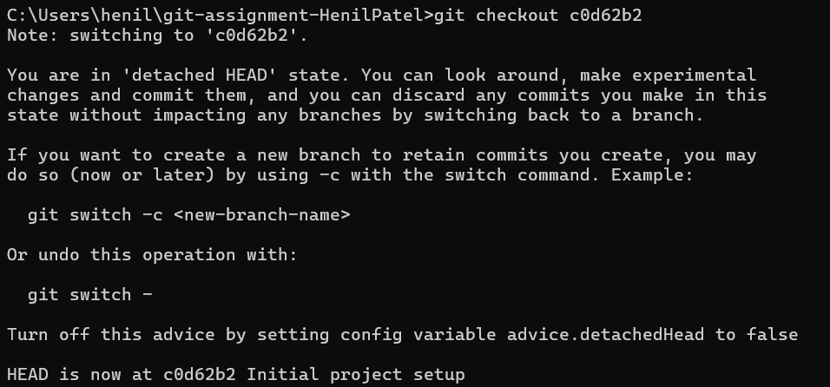
- Check current branch status
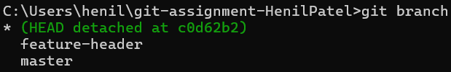
- Switch back safely to master
